ANSWERS TO ASSIGNMENT
1. Q-1. Write an SQL query to fetch “FIRST_NAME” from Worker table using the alias name as <WORKER_NAME>.

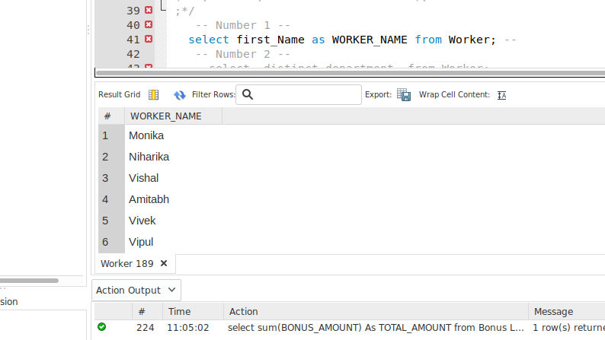
Q-2. Write an SQL query to fetch unique values of DEPARTMENT from Worker table.

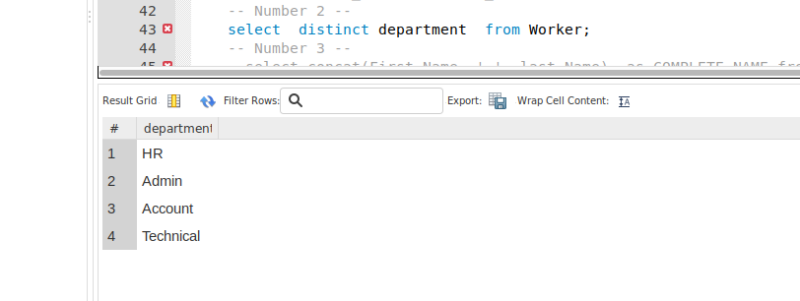
Q-3. Write an SQL query to print the FIRST_NAME and LAST_NAME from Worker table into a single column COMPLETE_NAME. A space char should separate them.
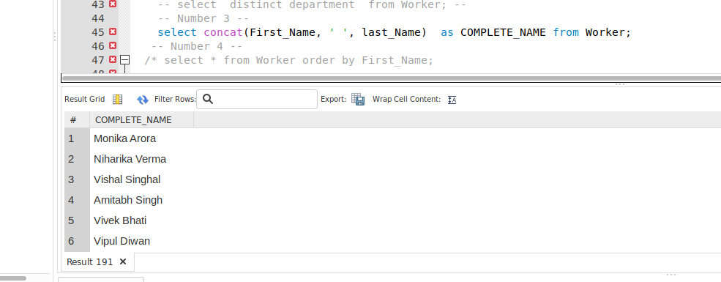

Q-4. Write an SQL query to print all Worker details from the Worker table order by FIRST_NAME Ascending.
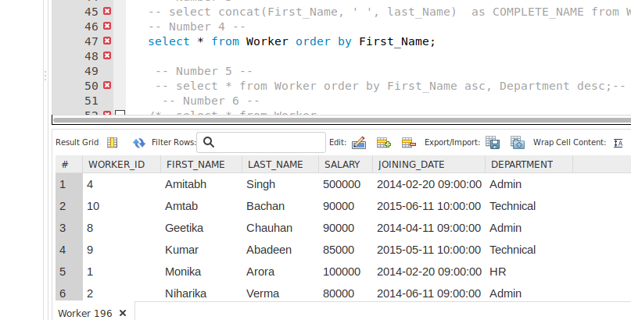

Q-5. Write an SQL query to print all Worker details from the Worker table order by FIRST_NAME Ascending and DEPARTMENT Descending.
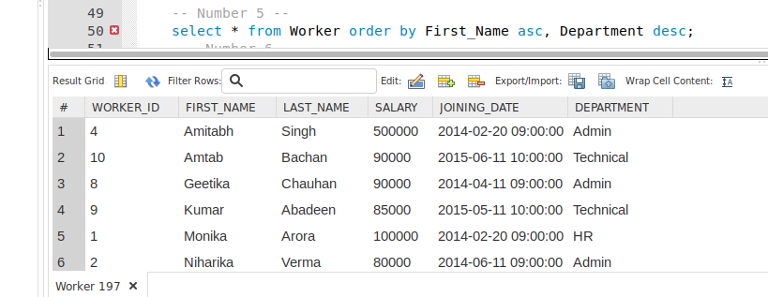

Q-6. Write an SQL query to print details for Workers with the first name as “Vipul” and “Satish” from Worker table.
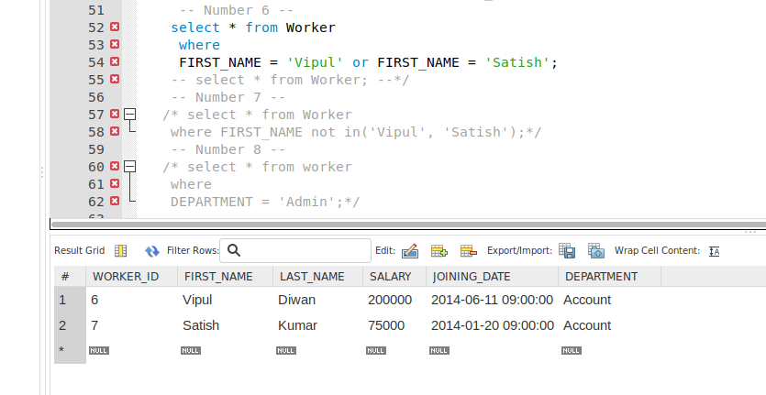

Q-7. Write an SQL query to print details of workers excluding first names, “Vipul” and “Satish” from Worker table.
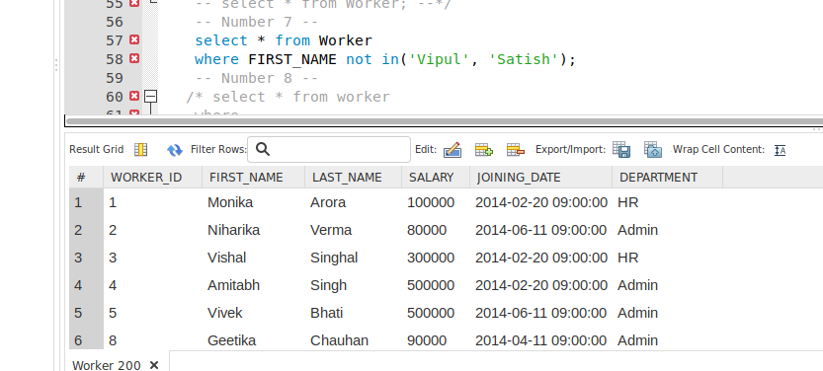

Q-8. Write an SQL query to print details of Workers with DEPARTMENT name as “Admin”.
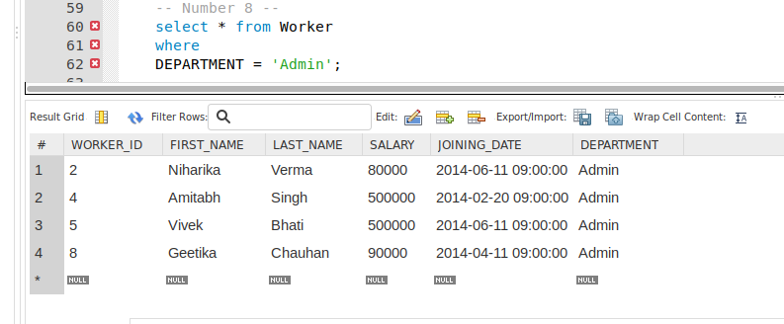

Q-9. Write an SQL query to print details of the Workers whose FIRST_NAME contains ‘a’.
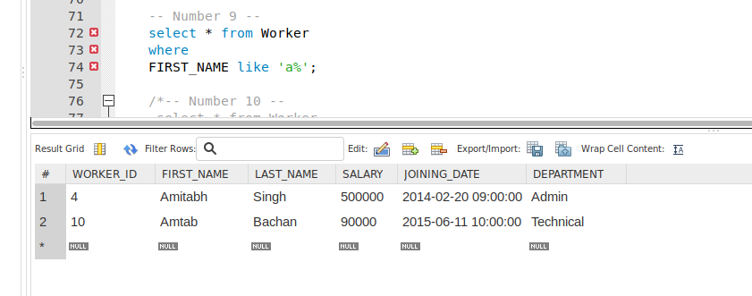

Q-10. Write an SQL query to print details of the Workers whose FIRST_NAME ends with ‘a’.
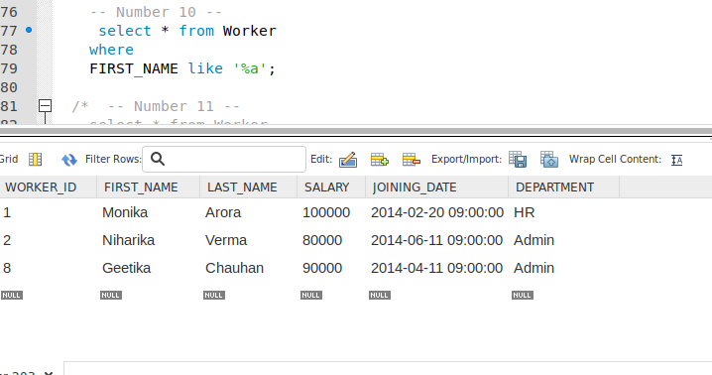

Q-11. Write an SQL query to print details of the Workers whose FIRST_NAME ends with ‘h’ and contains six alphabets.
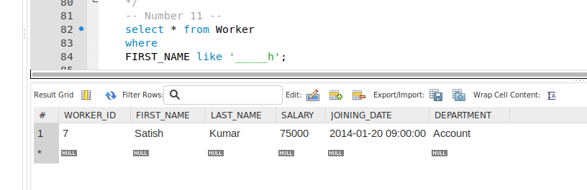

Q-12. Write an SQL query to print details of the Workers whose SALARY lies between 100000 and 500000.
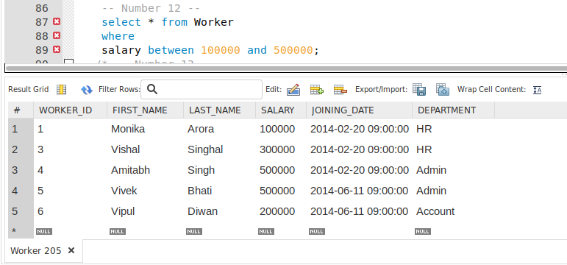

Q-13. Write an SQL query to fetch the count of employees working in the department ‘Admin’.
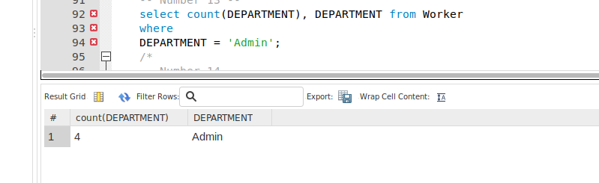

Q-14. Write an SQL query to fetch worker names with salaries >= 50000 and <= 100000.
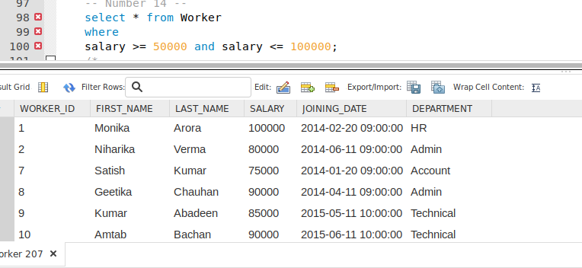

Q-15. Write an SQL query to print details of the Workers who are also Managers.
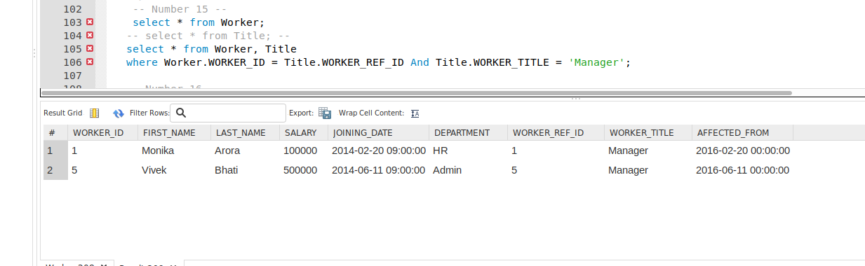

Q-16. Following MySQL query returns the current date and time:
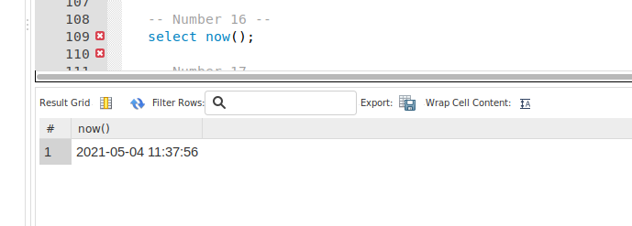

Q-17. Write an SQL query to show the top n (say 10) records of a table.
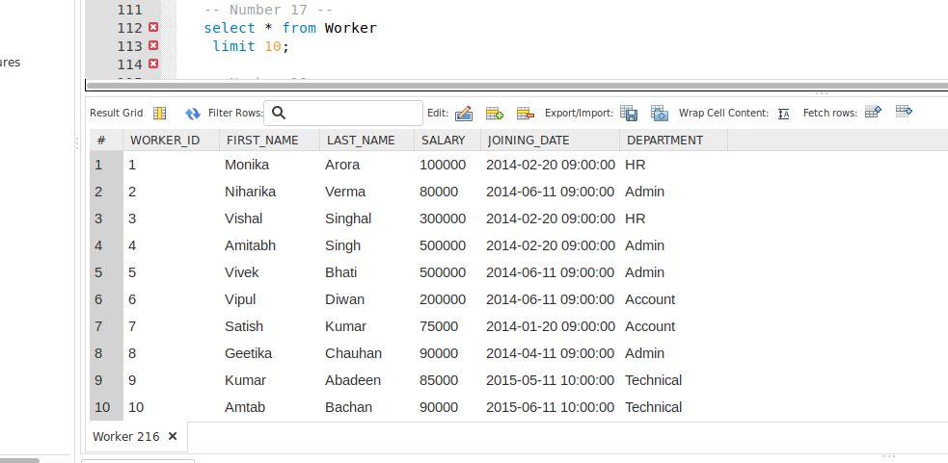

Q-18 Write a sql query to display the total and average amount the company pays in salary for all employees every month
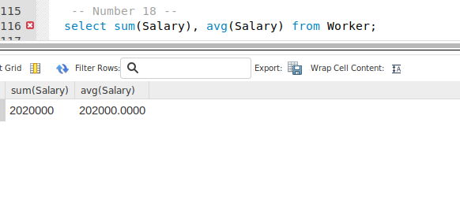

Q-19 Write a sql query to display the first name, last name and department of the highest paid employee within the organization
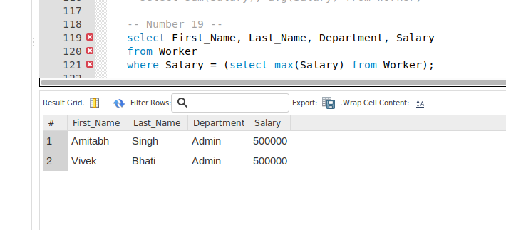

Q-20 Write a sql query to display the first name and last name with worker title of all executives in the organization
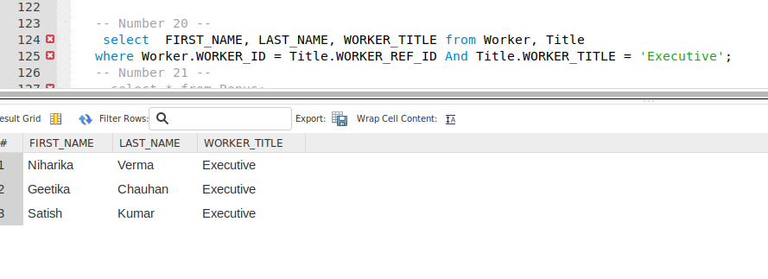

Q-21 Write a sql query to display the total amount the company pays in bonusfor all employees every month


